STEP 1:
- Email the EU-ACME office (contact@eu-acme.org) to request to be registered as a CME provider
- When confirmation received for registration as a CME provider follow the next steps

STEP 2:
- Complete PDF copies of the Conflict of Interest (CoI) forms
- Create an evaluation form (appendix 2)
- Email both CoI and evaluation forms to eaun@uroweb.org and s.mills@uroweb.org

STEP 3:
- Go to website https://eu-acme.org/ and log in
- EAUN members are automatically registered
- Non EAUN members or providers will need to register

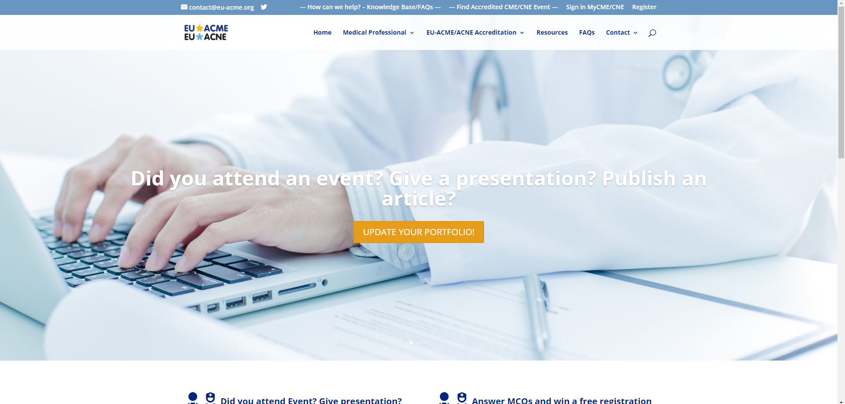

STEP 4:
- You will be taken to your log in page
- You need to select 'Request EU-ACME/ACNE accreditation' from the menu on the left
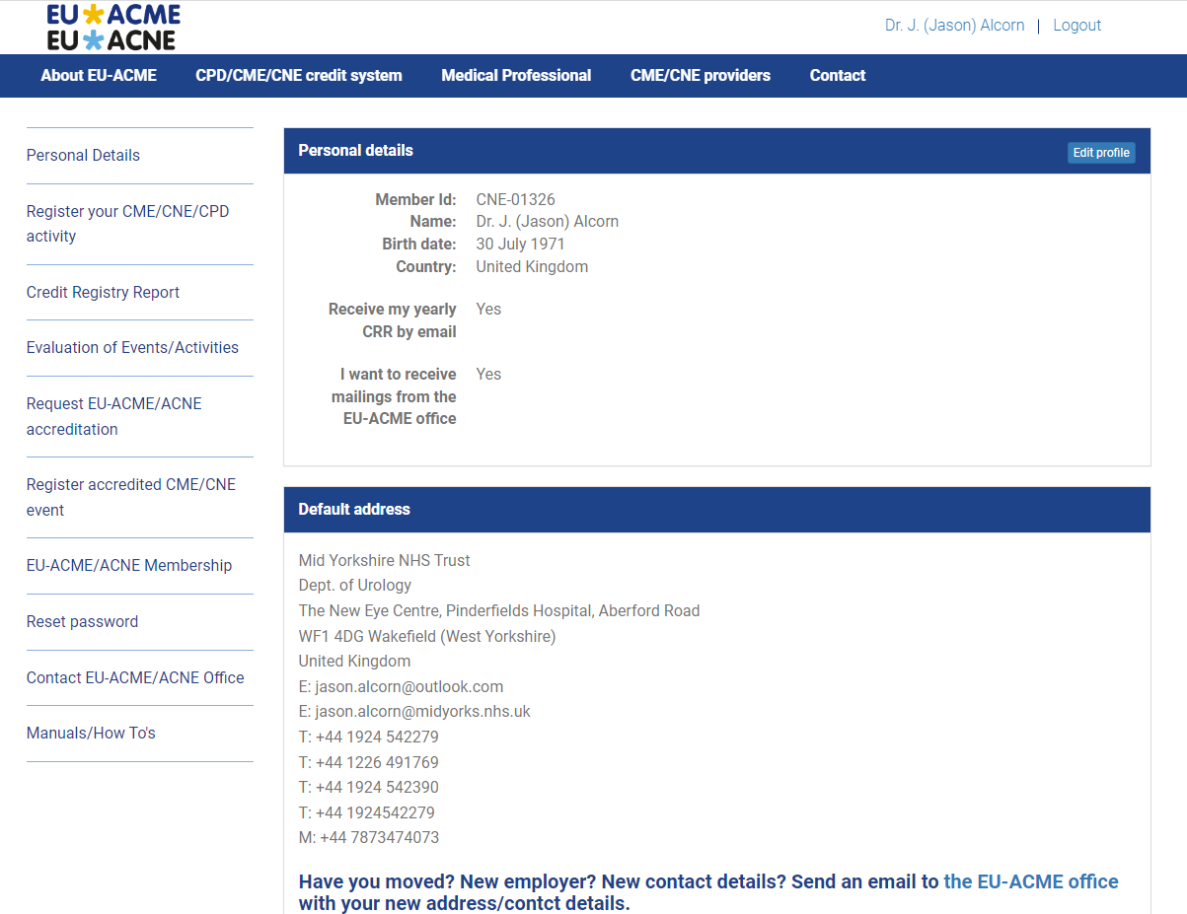
STEP 5:
Select 'Start New Application'

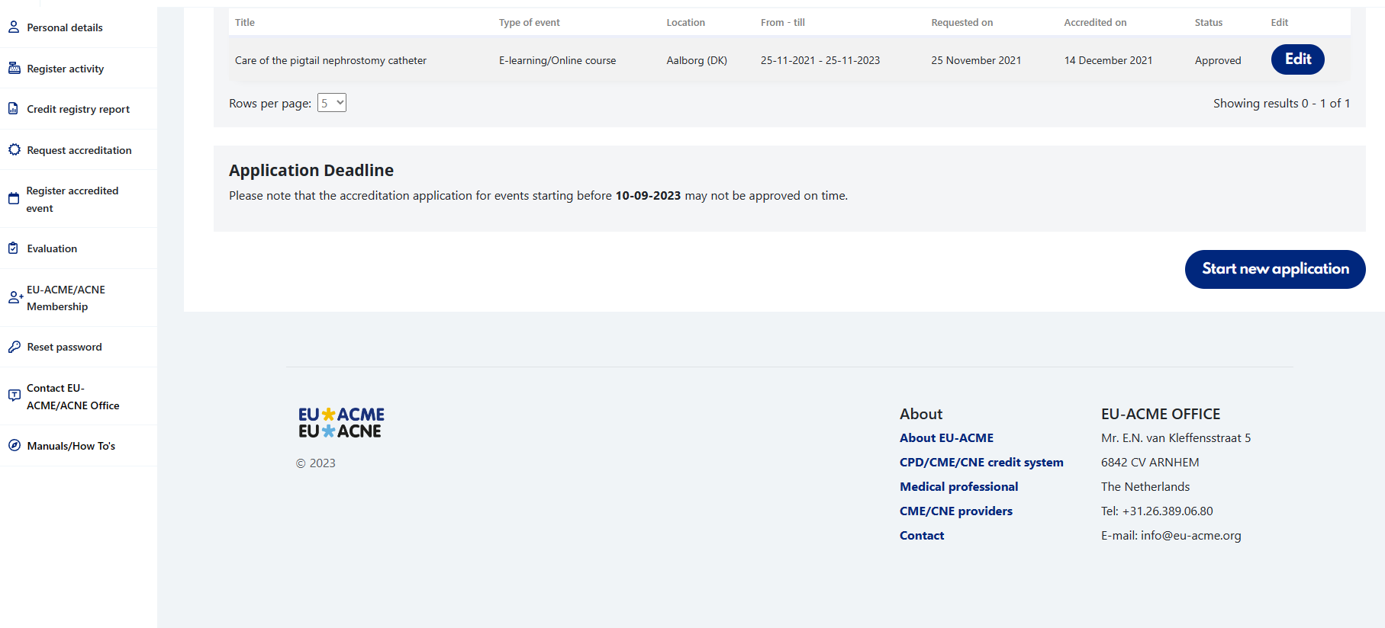

STEP 6:
- Complete application questions
- The answers in the right column in normal case and font can be copied and pasted directly into the answer boxes on the webpage if there is no drop down menu
- Example replies that are highlighted, require you to change for your webinar
- At the bottom right of each page select 'Next Step' when page questions complete

EVENT:
Title* | Assessment and nursing management of refractory chronic pelvic pain
Type of event * | Webinar; Virtual event (live)
Specialty | Urology Nurses
Original title | Can be left blank or insert title
Venue * | Online
City * | Amsterdam
Country * | Netherlands, The
Website * | https://nurses.uroweb.org/nurses/education-2/webinars/
Start date * | 16-03-2023
End date * | 16-03-2023

SELECT – ‘Next step: Event details’

EVENT DETAILS:
Number of participants/scientific hours * | Education hours – e-learning, hybrid/blended programmmes, webinars (1-8)
Target audience * | Registered nurses, specialised urology nurses, nurse practitioners, health care professionals
Clear description of event * | This webinar will provide an overview of evidence and knowledge gaps in psycho-social care in bladder cancer patients and give the participants an insight to the lived experience of bladder cancer patients. The webinar involves 5 lectures of 12 minutes by 5 different speakers with approx. 15 minutes discussion at the end.
Latest version of the programme * | Upload the programme
Needs assessment process and derived educational needs * | An online questionnaire was sent to the EAUN Members to assess their need for webinars, also their preferred topics. The outcome of the questionnaire was evaluated by the EAUN Board and based on the most popular topics, 3 EAUN Special Interest Groups were invited to create a topical webinar programme.
Expected educational outcome(s) * | - Improve awareness of psycho-social care in your clinical practice  - Increase your knowledge of unmet needs in BCa patients and the supportive role of the health care team  - Learn how to improve the patient’s experience during treatment and care
Methods to promote adult active learning * | Up to date references and guidelines for further reading embedded in the talks, ability to ask questions by chat, and talks followed by a discussion of the speakers where the questions will be answered and further discussed. Use of the chat will be encouraged by the moderator and speakers.
Learner engagement * | - Learners will have to create an account and register in advance.  - Duration of attendance during the live event is registered.  - Electronic evaluation form to be filled out directly after the webinar.  - Participants are invited by email to download the certificate. Before being able to download a certificate of attendance participants are asked to fill out MCQs to test engagement.
Selection criteria for faculty members * | Actively working in urology (research) or a related relevant field or active in relevant patient organisation; experienced and knowledgeable on the presented topic; being well-respected professionally; having no conflict of interest; having good speaker skills; being a member of EAU or EAUN in case of urology health care professionals.
Language * | English
Means for feedback of learners * | - The feedback form will include questions on the lecturer, presentation, content, value of each session and possible bias  - Electronic evaluation form to be filled out directly after the webinar  - Form includes rating of content, faculty, and learning outcomes, as well as possible bias and section for comments and ideas for future Webinars on continence care
Learners feedback form (evaluation form) * | Upload the Evaluation form (Appendix 2)

Distance Learning Content (DLC) - e-learning
Text website * | Not applicable
Test credentials * | Not applicable
Privacy and confidentiality of the learner * | Not applicable
Compliance of the DLC * | Not applicable
Level of evidence of the DLC * | Not applicable
Free from any commercial bias * | Sponsors’ names and logos, as well as adverts from the industry, do not appear on the home page, on all the pages with scientific/educational information, on the page with the accreditation statement.

SELECT - ‘Next step: Contacts’
CONTACTS
Contact person
Complete your details here

Provider
Organisation type* | Select National Society
Company name * | European Association of Urology Nurses
Address * | EAU Central Office  PO Box 30016
Postal code * | NL-6803 AA
City * | ARNHEM
State Province | If applicable
Country * | The Netherlands
E-mail * | eaun@uroweb.org
Phone number * | + 31 (0)26 389 06 80
VAT number | NL8200.09.088.B03
Short description of provider's organization * | The European Association of Urology Nurses (EAUN) represents approx. 3,000 nurses, all working in urological care. It is a lively, dynamic organisation with a focus on the importance of excellent urological nursing, especially for the patient.  As the representative body for European nurses in urology, we aim to foster the highest standards of urological nursing care throughout Europe and to facilitate the continued development of urological nursing in all its aspects.
Resolution of conflict of interests * | - Every faculty member must provide a declaration of COI as a second slide of his/her presentation and in MyEAU.  - The evaluation form completed by participants includes a question on the faculty’s bias.

Lead person / organisation responsible for the preparation, planning and administration of the event/e-learning
Select lead person* | Select

Medical practitioner who will take responsibility for the application
Select medical practitioner | Mr Mattia Boarin
Registration number * | 30663
Regularity authority * | Ordine Professioni Infermieristiche - Milano
Registration country * | Italy
Director's declaration * | Upload form in PDF format (Appendix 1)

Head of the Scientific and/or Organising Committee
Title * | Mr
First name* | Mattia
Last name* | Boarin
Company* | EAUN
Position* | Head of scientific committee
Address* | EAU Central Office  PO Box 30016
Postal Code* | NL-6803 AA
City* | ARNHEM
Country* | The Netherlands
Phone number* | + 31 (0)26 389 06 80
Conflict of Interest Disclosure Form - chairman * | Upload form in PDF format (appendix 1)
List of Scientific/Organising committee members * | Upload form in PDF format
Conflict of Interest Disclosure Form - members * | Upload form(s) in PDF format (appendix 1)

Invoice address
Select invoice address | Select other invoice address and input the following:
Name of agency* | EAUN
Address* | EAU Central Office  PO Box 30016
Postal Code* | NL-6803 AA
City* | ARNHEM
Country* | The Netherlands
Email address* | eaun@uroweb.org
Phone number* | + 31 (0)26 389 06 80
VAT number* | NL8200.09.088.B03

FUNDING OF THE EVENT
Commercial Support * | Yes
Source(s) of all funding * | Complete if known or state none
Schedule of fees for learners * | The European Association of Urology Nurses (EAUN) allocated part of the budget for the educational activities. The EAUN is a non-profit organisation.

CONFIRMATION
Checklist | Tick all boxes that apply
SUBMIT APPLICATION

APPENDIX 1

DIRECTOR’S DECLARATION

As the scientific director of the CNE/CPD programme EAUNwebinar: Improving efficiency within the robotic theatre taking place virtually on 25 January 2023 I declare that:

- The scientific programme of the course was developed under my supervision and responsibility, that it is scientifically balanced and without bias;

- All faculty and other speakers at this scientific event are aware of, and have agreed, upon the clauses of the EU-ACNE disclosure form, and have disclosed any potential conflict of interest that they may have. This must be stated at the beginning of the presentation and in all printed material;

- I am aware of the source and form of any commercial funding received to develop this programme;

- my signature appears on each Certificate distributed to all participants to this educational programme;

- I am aware of the type of evaluation form participants will have to complete at the end of the programme and agree to provide the necessary feed-back to the EU-ACME office;

- All printed material related to the above-mentioned programme does bear the EU-ACNE logo and accreditation statement in accordance with the relevant disclaimer.

- I accept responsibility for the payment of all fees to the EU-ACME office in connection with this application

The Director,
Mattia Boarin

Signature: (Electronic Signature)

Date:
9-1-2023
EU-ACNE Disclosure Form / Conflict of Interest
(Speaker/ moderator/ course director/SCO member)
It is the policy of EU-ACNE to ensure objectivity, balance, independence and a high scientific standard of educational programmes that receive accreditation.
All speakers/ chairpersons participating in these programmes are expected to disclose to EU-ACNE all potential conflicts of interest that might introduce a bias in the presentation.
The existence of potential conflicts of interest does not necessarily indicate a bias. However it is our ethical obligation to inform organizers and participants so that they are made aware of any relationship that might cause unintentional bias.
A potential conflict of interest may arise from various relationships, past or present, such as employment, consultancy, investments and stock ownership, funding for research, family relationship etc.
A potential bias relevant to the topic of the accredited programme/ text must be disclosed:
- at the beginning of the presentation for events
- on the introductory page of the CD ROM or Web module
- at the beginning or at the end of the CNE article/ text

Title of the programme:
EAUN webinar: Improving efficiency within the robotic theatre
---------------------------------------------------------------------------------------------------------------------------------------
(event)

Date (events only): 25 - 01 – 2023

Title of the presentation:
xxx

Name: xxx
Role: xxx

- I have no potential conflicts of interest to report
- I have the following potential conflicts of interest to report:

- Research contracts
- Consulting
- Employment in industry
- Stockholder of a healthcare company
- Owner of a healthcare company
- Others (please specify) :

--------------------------------------------------------------------------
Signature:

Date:

APPENDIX 2

Evaluation Form

EAUNwebinar
The format and content of future EAUN webinars are for a large part determined by the outcome of our surveys.
We appreciate your opinion very much and thank you for taking the time to fill out this questionnaire.

Specialty
¨ Nurse ¨ PhD/researcher ¨ Industry
¨ Nurse student ¨ Urologist/resident ¨ Other

Webinar evaluation (rating 1=bad, 2=poor, 3=fair, 4=good, 5=excellent)
Rate 1-5
How well did the webinar live up to your expectations?

Did the moderators convene the webinar well?

How would you rate the organisation of this webinar?

Do you feel that… (adapt as needed)
 | Yes |  | No
... through the webinar you gained knowledge that you can apply in your daily work? | Yes | To some extent | No
… the webinar will improve your patient care? | Yes | To some extent | No
... you gained new knowledge on commons concerns and fears experience by men living with prostate cancer | Yes | To some extent | No
... you gained new knowledge on how to assess concerns and fears | Yes | To some extent | No
... you gained new knowledge on strategies to manage support men and their families during times of fear and worry | Yes | To some extent | No
... you would recommend this webinar to your colleagues? | Yes | Don’t know | No
… the webinar is free of commercial bias? | Yes | To some extent | No

Speaker evaluation (rating 1=bad, 2=poor, 3=fair, 4=good, 5=excellent)
Faculty | Content  of lecture | Speaker presentation skills | Quality of  PPT presentation | Extent of interaction (discussion)
John McGrath
Sachin Malde
Rebecca Martin
Jørgen B. Jensen

Do you have any comments for speakers, suggestions for improvement or ideas for future webinars related to bladder cancer?
…………………………………………………………………………………………………………………………..
…………………………………………………………………………………………………………………………..
………………………………………………………………………………………………………………………..
…………………………………………………………………………………………………………………………..

Thank you and we hope to see you again soon

